**AZURE DEVOPS CODING CHALLENGE Q-1**

Q1. Create Azure Devops Environment and configuring Azure Devops Git Repository. Configure on your local git to implement this upload few test files on same.

CREATING AZURE DEVOPS ORGANIZATION:

Go to azure portal and click on azure devops. Below page appears in that click on “My azure Devops organizations”.

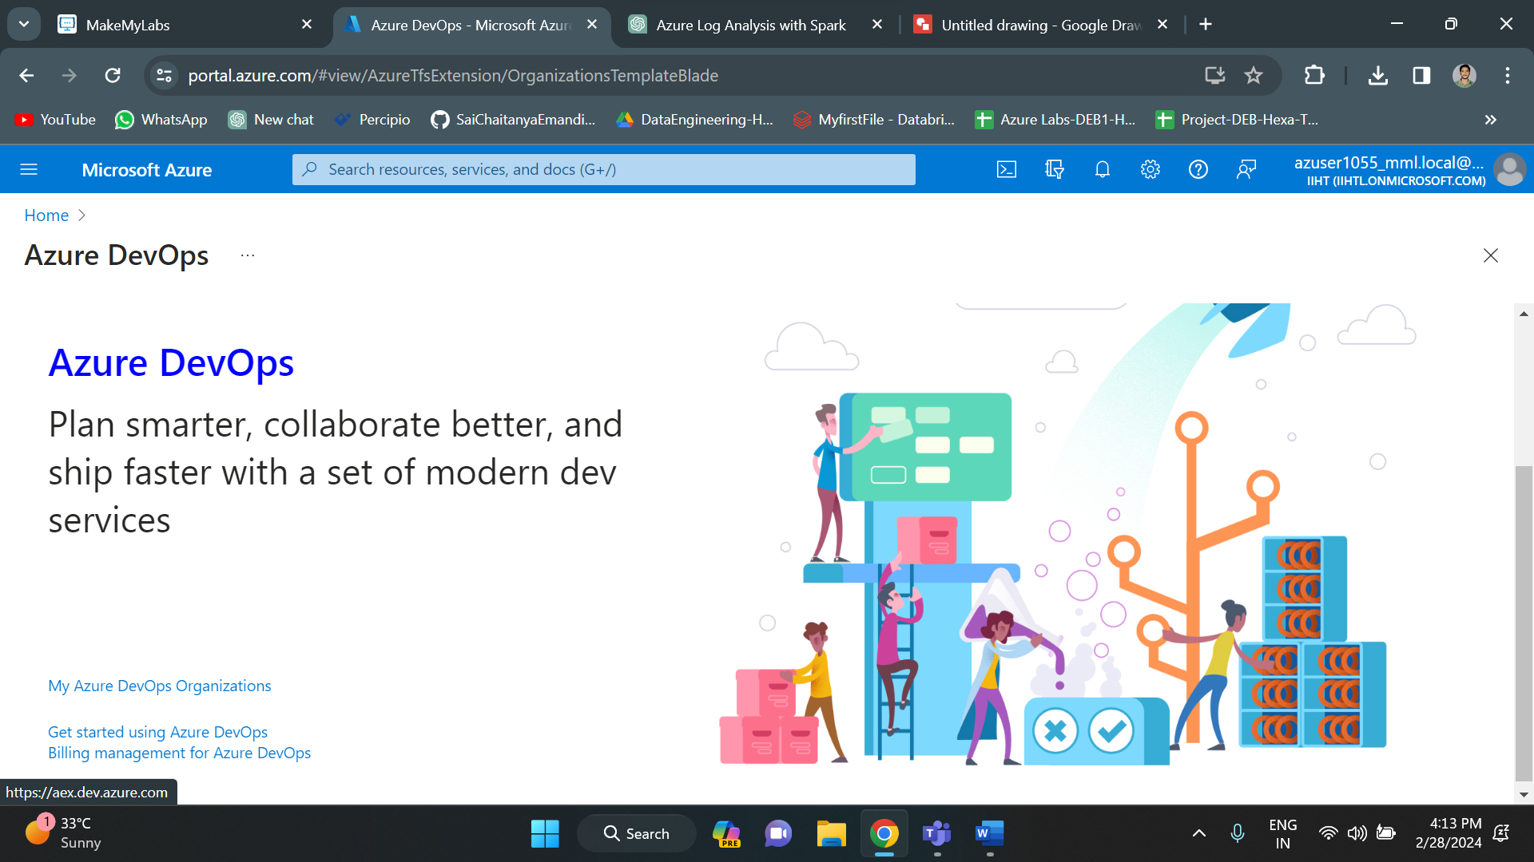

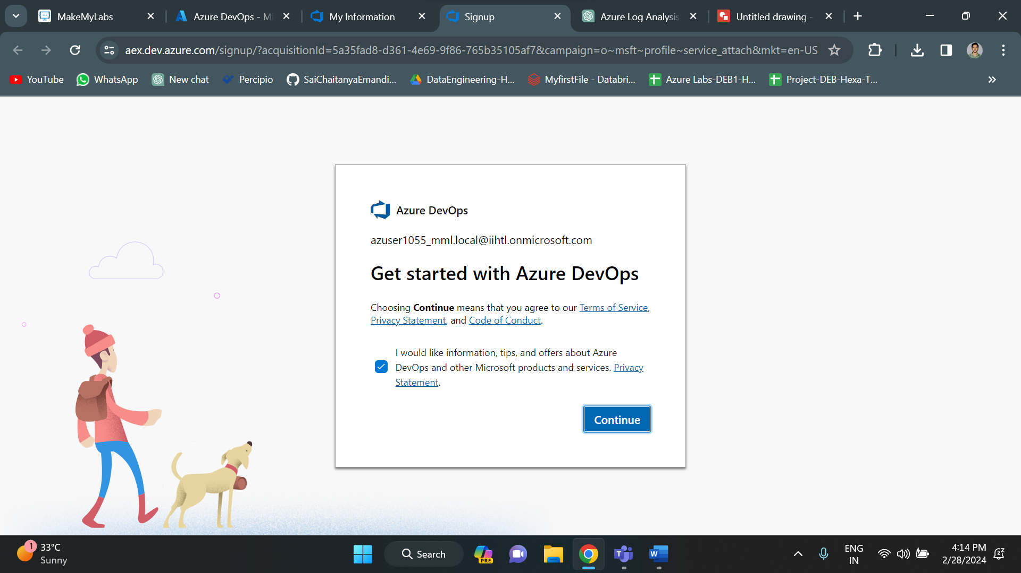

Creating a new project in “mydevops1055” organization

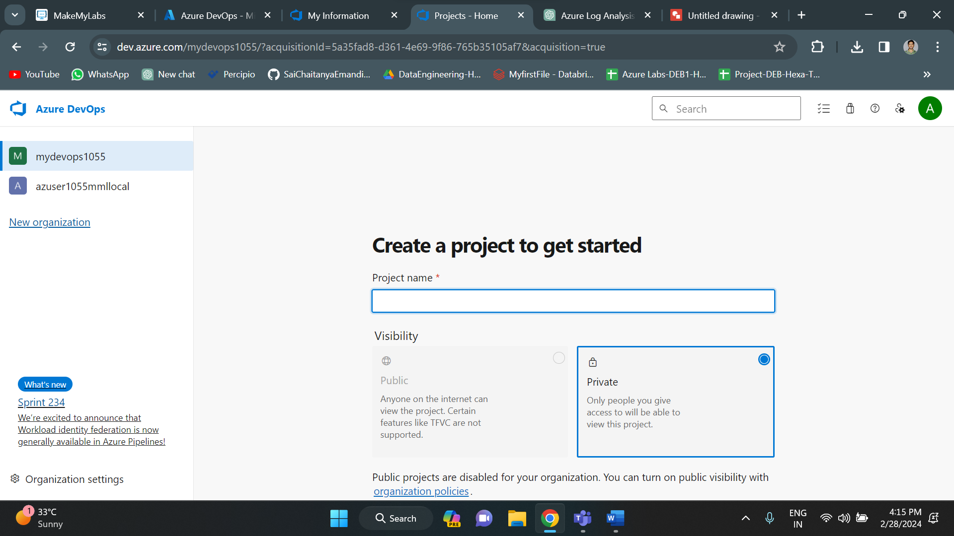

Once the project is successfully created, below home pages appears.

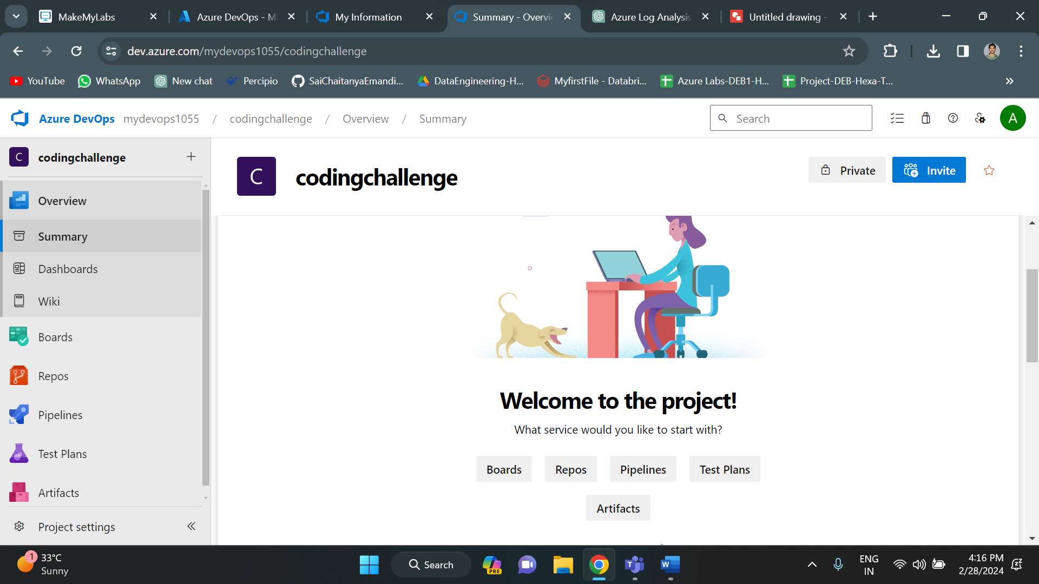

Click on repos.

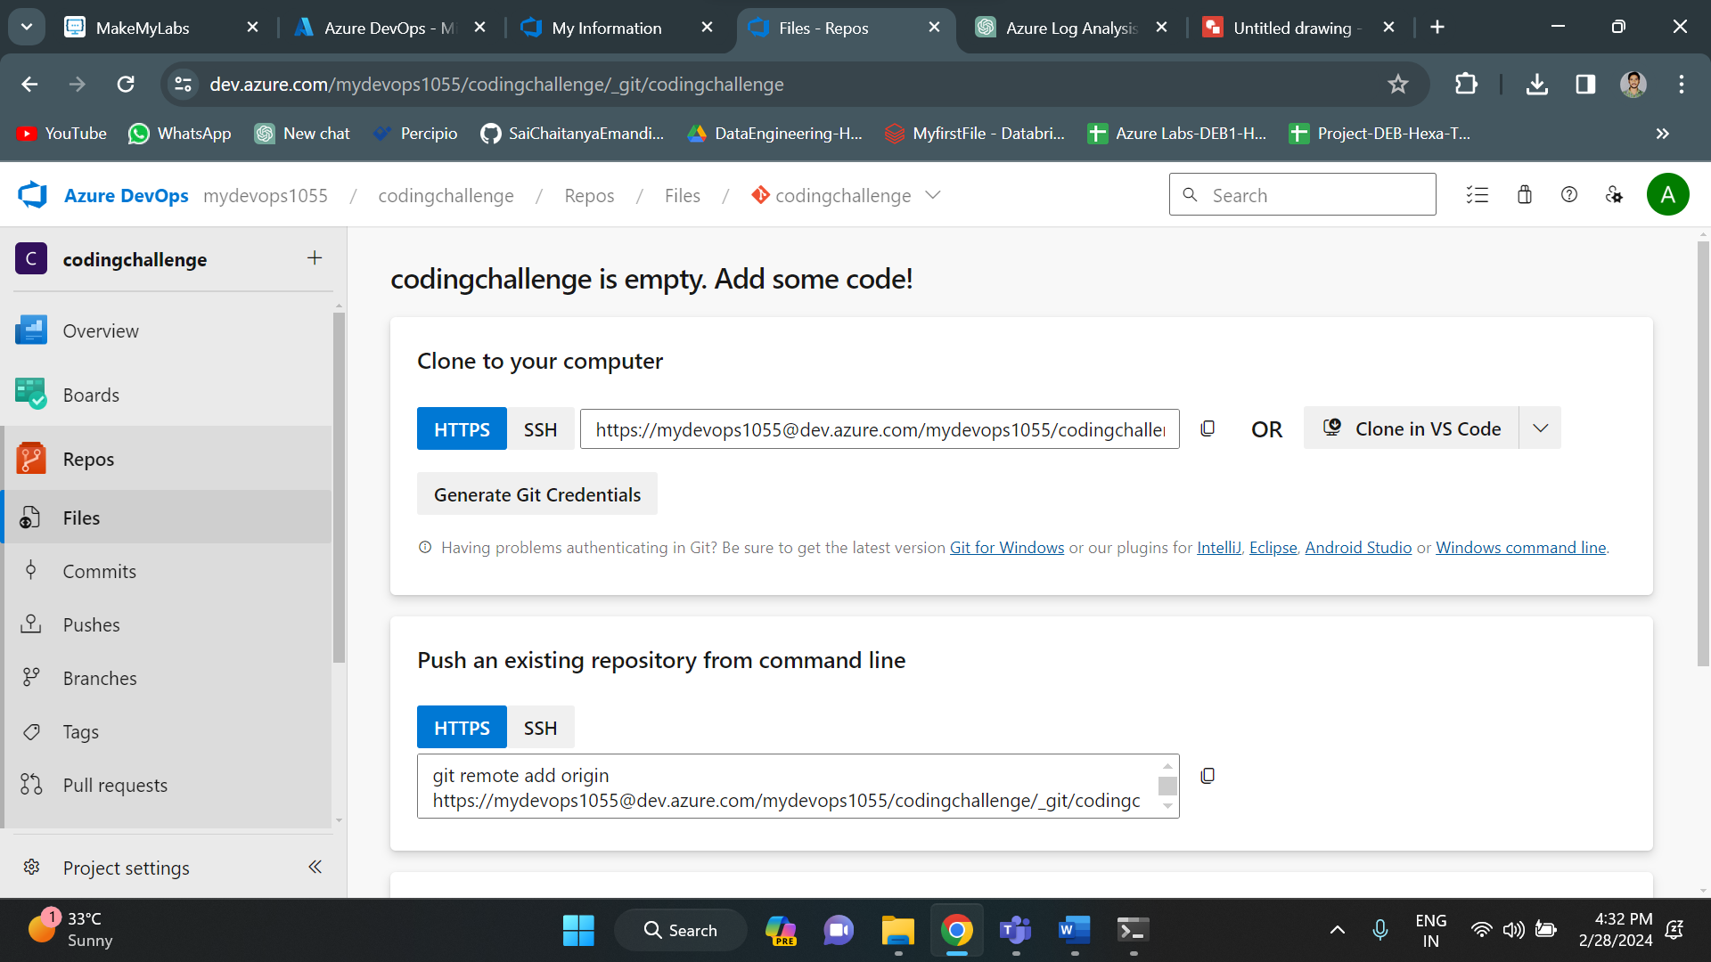

Go to coding_challenge and select new repository. Give name for it.

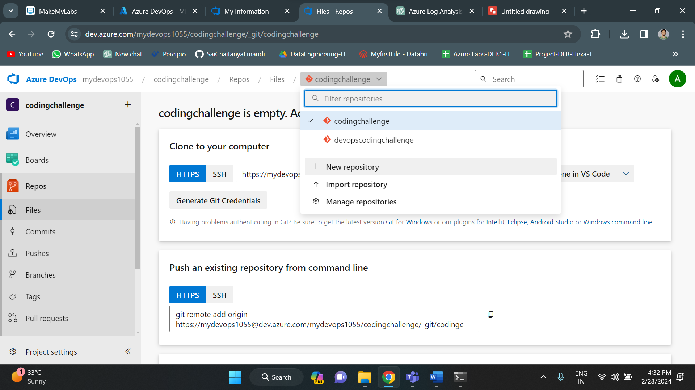

Click on clone repository and copy the link. Go to command prompt. In command prompt go to the respective directory and use the command git clone and then paste the url.

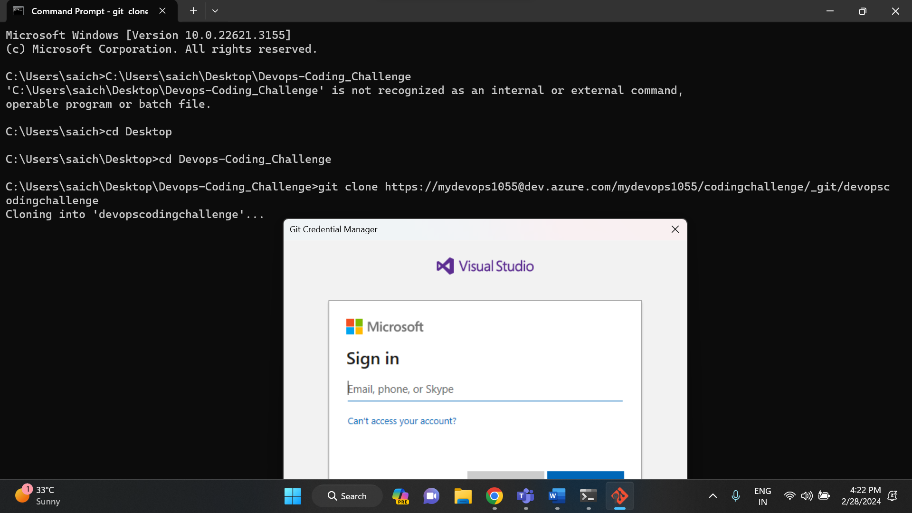

It will ask you to sign in. Give the credentials and sign in. After that, it gets successfully cloned.

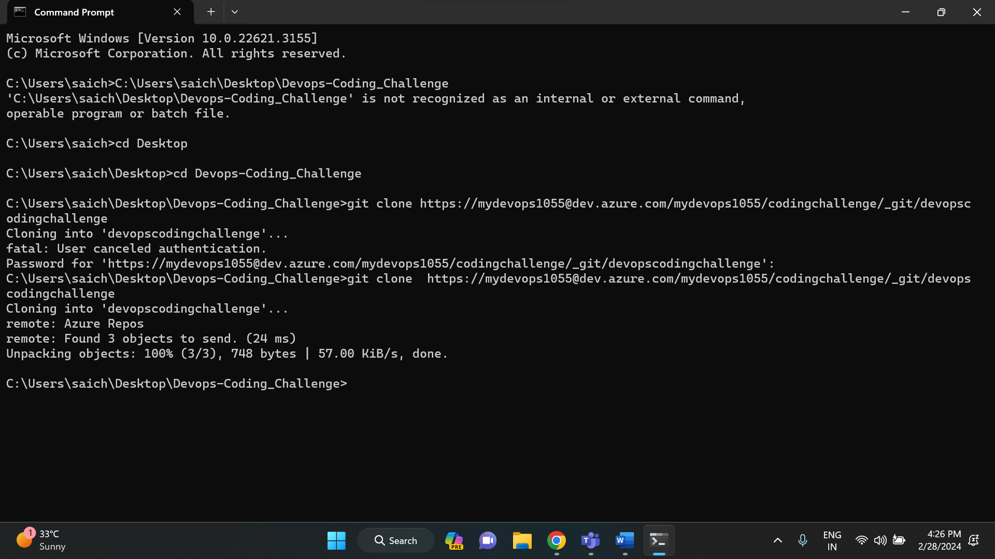

After you finish cloning the project, to the respective directory and run the following git commands.

1. Git init - to initialize and empty git repository
2. Git add . – to select all the files to add it to the repository
3. Git status – to check the status
4. Git commit – to commit the steps done
5. Git push – push command is used to push the files into the selected repository.

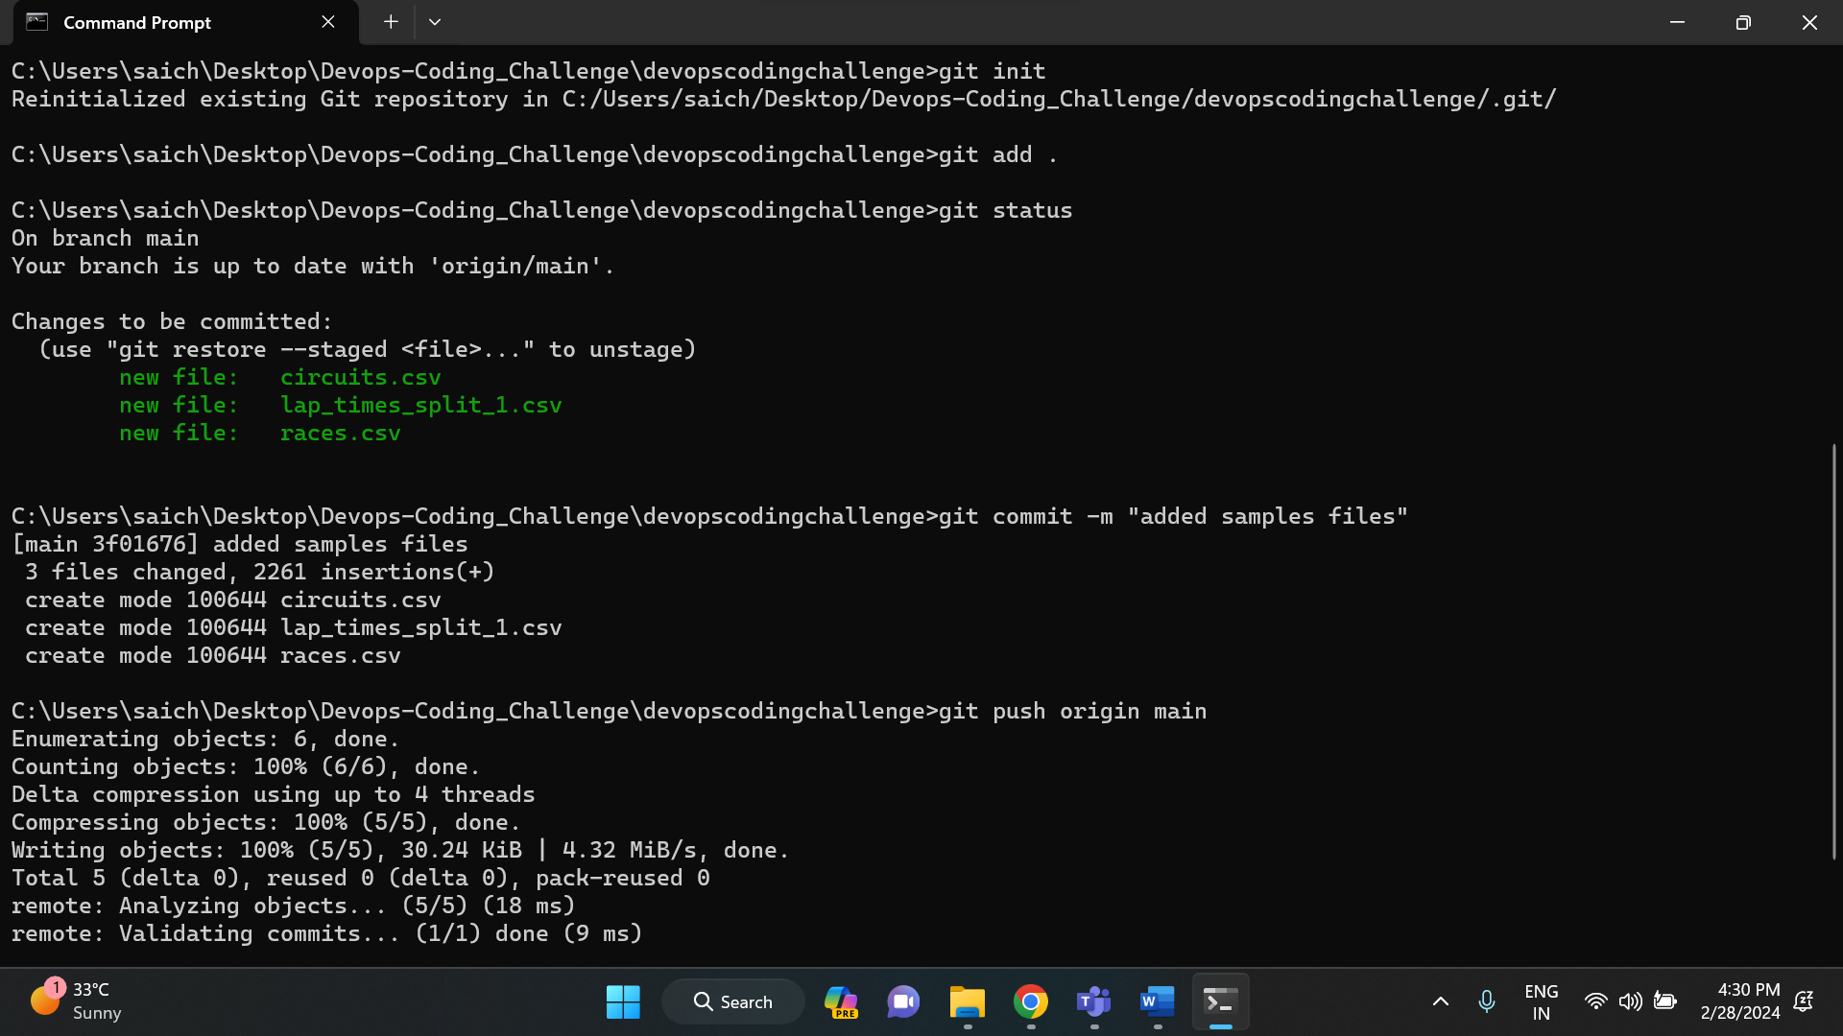

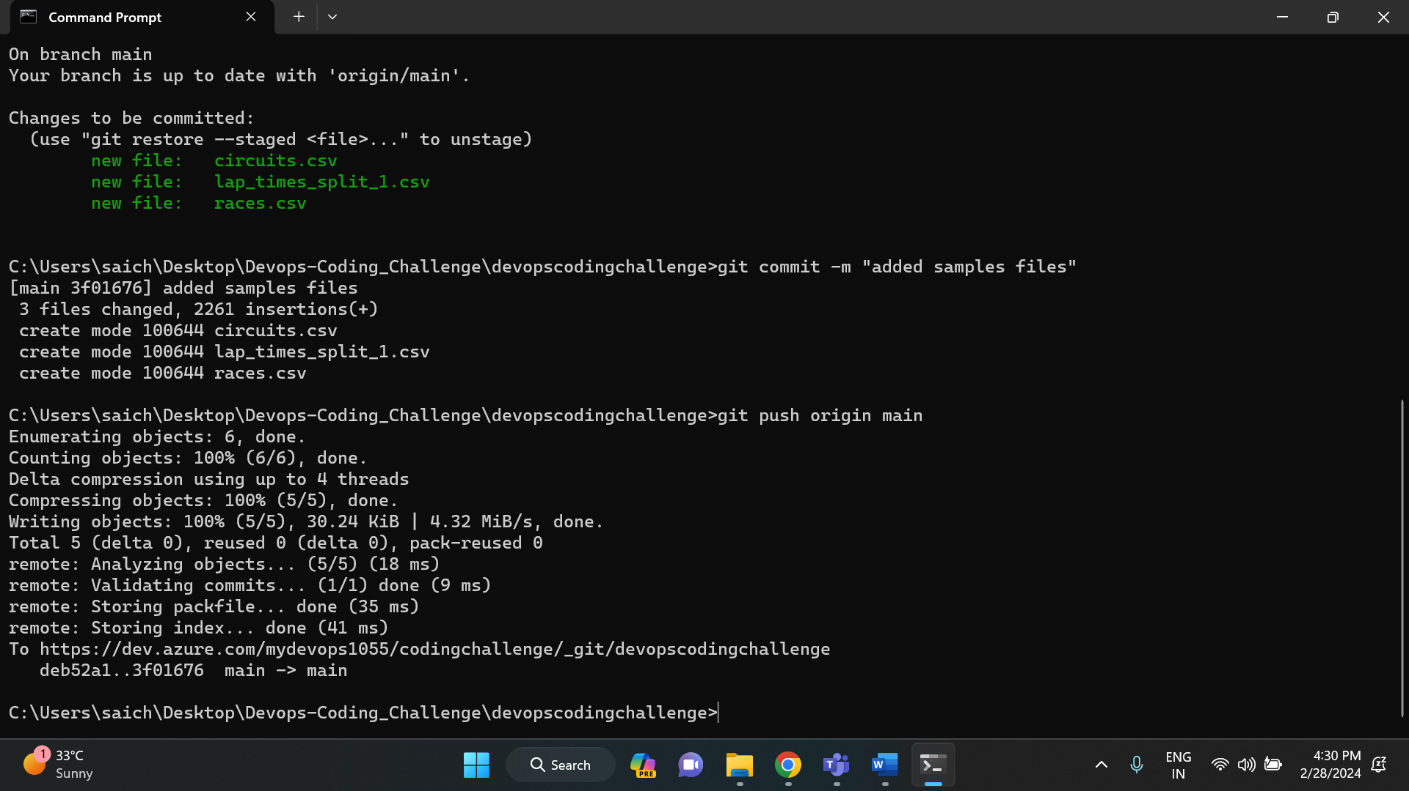

After the push command, go to devops page and refresh it. You will see all the files that you have selected and pushed.

